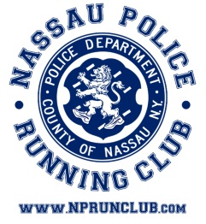

**NASSAU POLICE RUNNING CLUB**

**SCHOLARSHIP APPLICATION**

APPLICANT’S NAME:__________________________________________

ADDRESS:_____________________________________________________

PHONE:________________________________________________________

RELATIONSHIP TO MEMBER:_____________________________________

MEMBER’S NAME AND SERIAL NO:________________________________

COMMAND: _____________________CELL PHONE NO: ______________________

DATE OF APPLICATION: ______________________________________

Two awards will be given in the amount of $500.00 each to students who are currently or will be full time college students. Winners are chosen on a lottery basis. In the event that the winner is unable to accept the award because of other scholarship awards, the money will be presented to the next successful applicant.

**REQUIREMENTS**

This scholarship is open to any dependent children of an active member of the Nassau Police Running Club in good standing for three years prior to applying.

Applications will be accepted until June 15 of the application year.

Send application to:

NPRC

PO Box 1599

Mineola, NY 11501

*Applicant must furnish proof of enrollment in college or university before the scholarship money can be awarded.